# Partitioning and Normalization

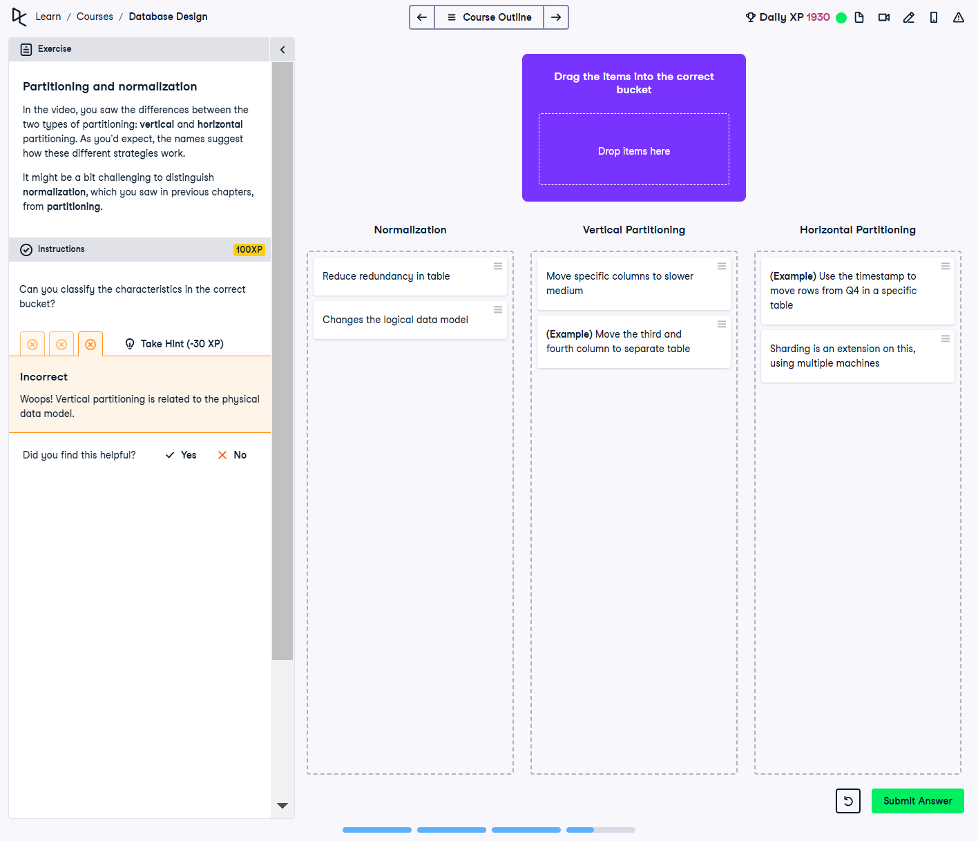

## Question:

In this exercise, you need to correctly classify the characteristics of **Normalization**, **Vertical Partitioning**, and **Horizontal Partitioning** into the appropriate category.

## Correct Classification:

### Normalization:

1. Reduce redundancy in table

2. Changes the logical data model

### Vertical Partitioning:

1. Move specific columns to a slower medium

2. (Example) Move the third and fourth column to a separate table

### Horizontal Partitioning:

1. (Example) Use the timestamp to move rows from Q4 into a specific table

2. Sharding is an extension of this, using multiple machines

## Explanation:

Normalization focuses on **reducing redundancy** and improving data integrity by structuring the database in a logical way. **Vertical Partitioning** deals with breaking tables into smaller physical structures based on columns. **Horizontal Partitioning**, on the other hand, splits data based on rows, commonly using timestamps or IDs. Sharding is a form of horizontal partitioning that distributes data across multiple machines.